|  |  |  |  |
| --- | --- | --- | --- |
| 1 | | 5,016 | |
| **NUMERO DE FRONTERAS** | | **ENERGIA AGREGADA** | |
|  | | | |
| 547,449 | 5 | | 20,587 |
| INGRESO 2019 | DÍAS CERTIFICADOS 2019 | | ENERGIA RESPALDADA 2019 |
|  | | | |
| 6,105,040 | 61 | | 234,646 |
| INGRESO 2020 | DÍAS CERTIFICADOS 2020 | | ENERGIA RESPALDADA 2020 |
|  | | | |
| 3,688,277 | 34 | | 170,505 |
| INGRESO 2021 | DÍAS CERTIFICADOS 2021 | | ENERGIA RESPALDADA 2021 |

**HISTORICO REINTEGRO DDV**

|  |  |  |  |
| --- | --- | --- | --- |
|  | **2019** | **2020** | **2021** |
| **ENE** | - | - | - |
| **FEB** | - | - | - |
| **MAR** | - | - | - |
| **ABR** | - | - | - |
| **MAY** | - | - | - |
| **JUN** | 0.31 | - | - |
| **JUL** | - | 3.07 | - |
| **AGO** | 0.24 | 3.04 | - |
| **SEP** | - | - | 1.86 |
| **OCT** | - | - | 1.83 |
| **NOV** | - | - | - |
| **DIC** | - | - | - |

**Los valores de la tabla están en millones de COP**

**REINTEGRO MECANISMO DDV OCTUBRE 2021**

|  |  |  |  |  |  |
| --- | --- | --- | --- | --- | --- |
| FECHA | TIPO DIA | CANTIDADES RESPALDO | PRECIO PONDERADO USD | TRM | PNETO |
| 2021-10-01 | Viernes | 5,015 | 5.98 | 3,784.44 | 101,691 |
| 2021-10-02 | Sábado | 5,015 | 5.98 | 3,784.44 | 101,691 |
| 2021-10-03 | Domingo - Festivo | 5,015 | 5.98 | 3,784.44 | 101,691 |
| 2021-10-04 | Lunes | 5,015 | 5.98 | 3,784.44 | 101,691 |
| 2021-10-05 | Martes | 5,015 | 5.98 | 3,784.44 | 101,691 |
| 2021-10-06 | Miércoles | 5,015 | 5.98 | 3,784.44 | 101,691 |
| 2021-10-07 | Jueves | 5,015 | 5.98 | 3,784.44 | 101,691 |
| 2021-10-08 | Viernes | 5,015 | 5.98 | 3,784.44 | 101,691 |
| 2021-10-09 | Sábado | 5,015 | 5.98 | 3,784.44 | 101,691 |
| 2021-10-10 | Domingo - Festivo | 5,015 | 5.98 | 3,784.44 | 101,691 |
| 2021-10-11 | Lunes | 5,015 | 5.98 | 3,784.44 | 101,691 |
| 2021-10-18 | Domingo - Festivo | 5,015 | 5.98 | 3,784.44 | 101,691 |
| 2021-10-19 | Martes | 5,015 | 5.98 | 3,784.44 | 101,691 |
| 2021-10-20 | Miércoles | 5,015 | 5.98 | 3,784.44 | 101,691 |
| 2021-10-21 | Jueves | 5,015 | 5.98 | 3,784.44 | 101,691 |
| 2021-10-22 | Viernes | 5,015 | 5.98 | 3,784.44 | 101,691 |
| 2021-10-23 | Sábado | 5,015 | 5.98 | 3,784.44 | 101,691 |
| 2021-10-24 | Domingo - Festivo | 5,015 | 5.98 | 3,784.44 | 101,691 |

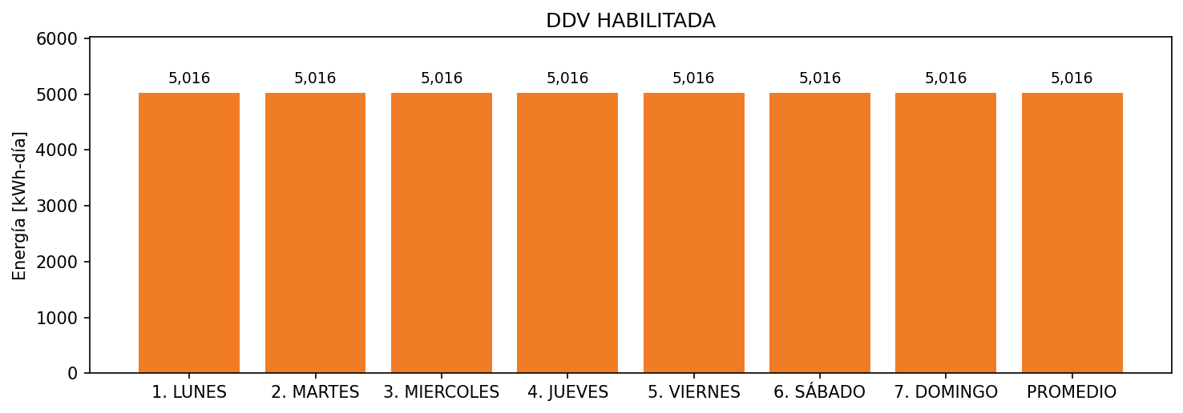

|  |  |  |  |  |  |  |  |  |  |
| --- | --- | --- | --- | --- | --- | --- | --- | --- | --- |
| **FRONTERA** | **COD SIC** | **FRT DDV** | **TIPO DDV** | **PROMEDIO** | **PRÓXIMA ACTUALIZACIÓN** | **MARGEN DE ERROR** | **ÚLTIMA PRUEBA DDV** | **DÍAS PARTICIPACIÓN** | **FECHA REFERENCIA PRÓXIMA PRUEBA DDV** |
| ESTELAR MILLA DE ORO | Frt08135 | Frt38841 | GPE | 5,016 | 2026-04-15 | NO APLICA | 2021-09-05 | 34.0 | 2022-01-31 |